Angular 21 NgRx Signal Store

The NgRx SignalStore is a lightweight, fully reactive state management library built natively on top of Angular Signals. It uses a functional, plugin-based architecture that eliminates the traditional boilerplate of actions, reducers, and selectors. [1]
Here is a step-by-step guide to setting up and using the NgRx SignalStore in an Angular application. [1]

- Create SignaleStore application

C:\>cd/
C:\>cd Angular
C:\Angular>ng new SignalStore
C:\Angular>cd SignalStore
C:\Angular\SignalStore>code .
Now, you have opened the application in VS Code
- Start a new Terminal in VS Code. Install the core signals package via the Angular CLI

ng add @ngrx/signals@^21

- Generate a new ToDos component
ng g c ToDos

- Creating a SignalStore
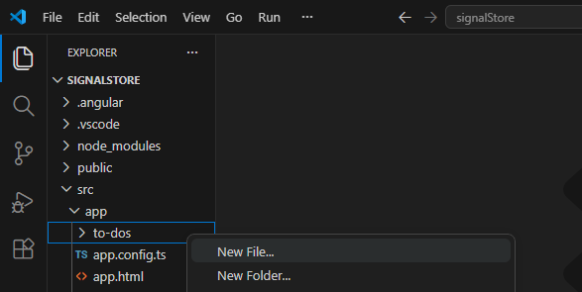

Right-click the component project folder, create a new todos-store.ts file
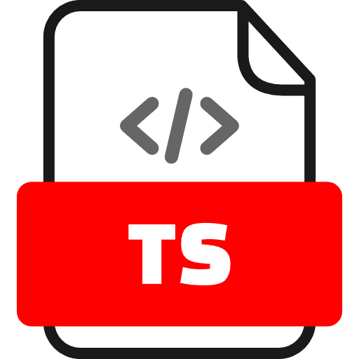
//todos-store.ts
import { signalStore, withState, withComputed, withMethods, patchState } from '@ngrx/signals';
import { computed } from '@angular/core';

// Define the shape of our state
export interface Todo {
id: number;
title: string;
completed: boolean;
}

export interface TodosState {
todos: Todo[];
loading: boolean;
}

const initialState: TodosState = {
todos: [],
loading: false,
};

// Create the reactive store
export const TodosStore = signalStore(
{ providedIn: 'root' }, // Makes the store globally accessible as a singleton service
withState(initialState), // Initializes state slices as read-only Signals

// Define derived/computed state slices
withComputed(({ todos }) => ({
completedCount: computed(() => todos().filter(t => t.completed).length),
pendingCount: computed(() => todos().filter(t => !t.completed).length),
})),

// Define methods to update state
withMethods((store) => ({
async addTodo(title: string) {
// Use patchState to immutably update state slices
patchState(store, (state) => ({
todos: [...state.todos, { id: Date.now(), title, completed: false }],
}));
},
async toggleTodo(id: number) {
patchState(store, (state) => ({
todos: state.todos.map((todo) =>
todo.id === id ? { ...todo, completed: !todo.completed } : todo
),
}));
},
async setLoading(loading: boolean) {
patchState(store, { loading });
},
}))
);

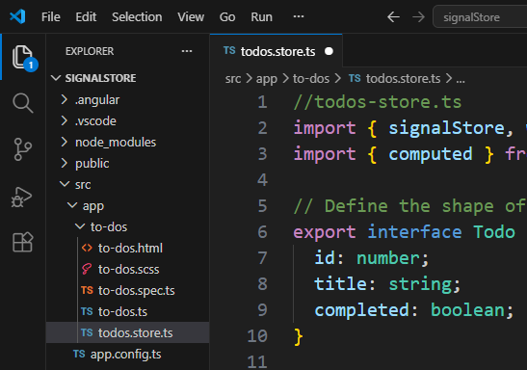

- Consuming the Store in a Component
Inject the store like any typical Angular service. State slices and computed values are automatically available as ready-to-use read-only Signals. [1, 2, 3, 4]
//to-dos.ts
import { Component, inject } from '@angular/core';
import { CommonModule } from '@angular/common';
import { TodosStore } from './todos.store';

@Component({
selector: 'app-todos',
standalone: true,
imports: [CommonModule],
templateUrl:'to-dos.html',
})
export class ToDos{
// Inject the store directly into the component
readonly store = inject(TodosStore);
}
- Prepare the template file to-dos.html

<h3>Todo Tracker</h3>
<p>Completed: {{ store.completedCount() }} | Pending: {{ store.pendingCount() }}</p>

<input #todoInput type="text" placeholder="Add a new task..." />
<button (click)="store.addTodo(todoInput.value); todoInput.value = ''">Add</button>

<ul>
@for(todo of store.todos();track todo.id){
<li [style.textDecoration]="todo.completed ? 'line-through' : 'none'"
(click)="store.toggleTodo(todo.id)">
{{ todo.title }}
</li>
}
</ul>
- In app.ts file
import { Component, signal } from '@angular/core';
import { RouterOutlet } from '@angular/router';
import { ToDos } from './to-dos/to-dos';

@Component({
selector: 'app-root',
imports: [RouterOutlet, ToDos],
templateUrl: './app.html',
styleUrl: './app.scss'
})
export class App {
protected readonly title = signal('signalStore');
}

- In app.html file
<app-todos/>
<router-outlet />

- Save All files and Test the application
ng serve --open

The web browser
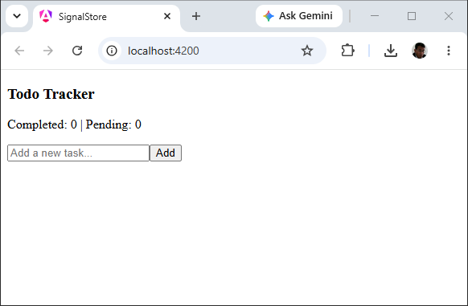
Try add the following items:
- Apple
- Ciku
- Durian
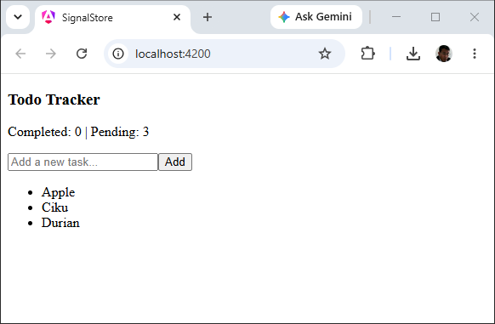
Try click on Ciku and Durian
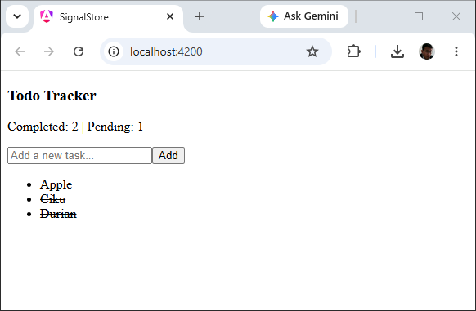
Try click on Durian again
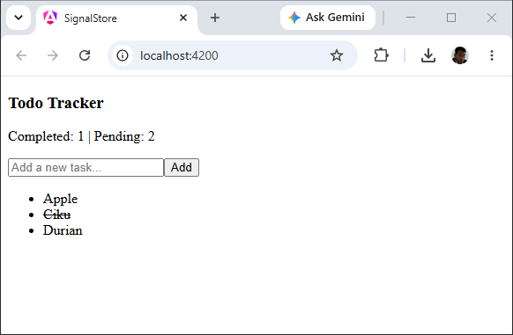
- Shut down the application

Key Takeaways
- withState: Auto-generates read-only signals for each top-level key defined in your initial state. [1, 2]
- patchState: A standalone utility that accepts the store instance and updates the state immutably. It accepts either a partial state object or a callback function for dynamic updates. [1, 2]
- No async Pipe Needed: Because the properties are native Signals, you read them directly by calling them as functions (e.g., store.todos()) in your template, allowing Zone-free or change-detection-efficient rendering. [1, 2]

